K.R. MANGALAM UNIVERSITY

SCHOOL OF ENGINEERING & TECHNOLOGY
2025-26



LAB PRACTICAL FILE
OPERATING SYSTEM LAB
COURSE CODE: ENCS351

NAME: SIDDHANT JHA
ROLL NO.: 2301730219
SECTION: D
COURSE: BTECH CSE (AI & ML)
SUBMITTED TO: MS. SUMAN
INDEX

Number of experiments | Experiments
1 | Simulate different types of operating systems using Python or Linux commands.
2 | Simulate CPU scheduling algorithms (FCFS, SJF, Round Robin, Priority). Generate Gantt chart, compute average waiting and turnaround time.
3 | Simulate Worst-fit, Best-fit, and First-fit memory allocation.
4 | Implement Banker’s Algorithm for deadlock avoidance/prevention.
5 | Implement Producer-Consumer problem using semaphores.
6 | Process synchronization using semaphores.
7 | Use UNIX/Linux I/O system calls (open, read, write, close, seek, stat).
8 | System Startup, Process Creation, and Termination  Simulation in Python
9 | Create and manipulate threads in Python.
10 | Process Creation and Management Using Python OS  Module
11 | File System Operations using Python

EXPERIMENT – 1
Simulate different types of operating systems using Python or Linux commands.

(1) Batch Processing OS
CODE:
# Batch Processing Simulation import time

processes = ["Job1", "Job2", "Job3"]

print("--- Batch Processing OS Simulation ---") for job in processes: print(f"Processing
{job}...") time.sleep(0.5)

print("All batch jobs completed.")

OUTPUT-

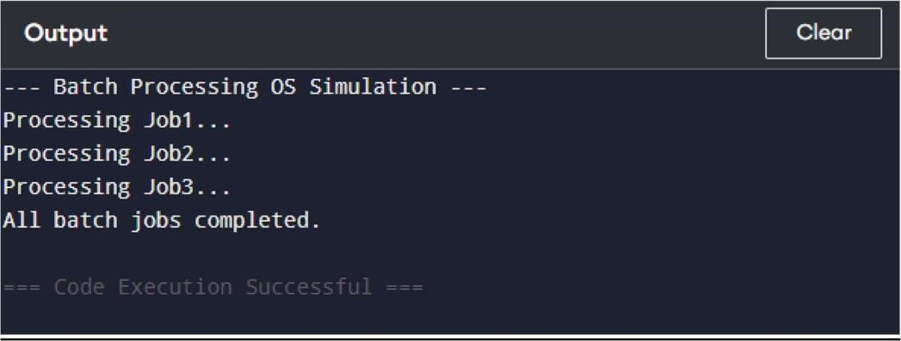

Multiprogramming OS CODE:
# Multiprogramming Simulation
processes = ["Program1", "Program2", "Program3"]

print("--- Multiprogramming OS Simulation ---") print("Multiple programs are loaded in memory...")

for p in processes:
print(f"{p} is ready/blocked/running simultaneously.")

print("Multiprogramming execution simulated.")

OUTPUT-

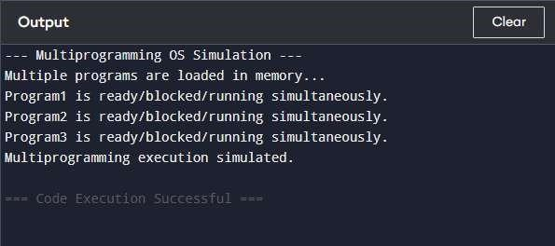

Multitasking OS

CODE:

# Multitasking Simulation import time

tasks = ["Task1", "Task2", "Task3"]

print("--- Multitasking OS Simulation ---")
print("CPU rapidly switches between tasks...")
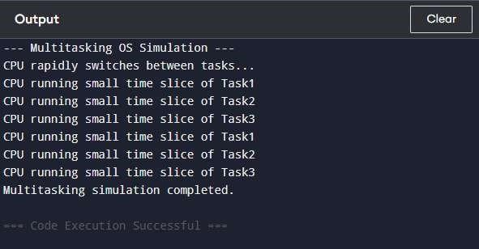

for _ in range(2): # simulate 2 cycles for t in tasks: print(f"CPU running small time slice of {t}") time.sleep(0.3)

print("Multitasking simulation completed.")

OUTPUT-

Real-Time OS
CODE:
# Real-Time OS Simulation tasks
= ["T1", "T2", "T3"]

print("--- Real-Time OS Simulation ---") for t in tasks:
print(f"Task {t} must complete within strict deadline!")

print("Real-time tasks executed.")

OUTPUT-

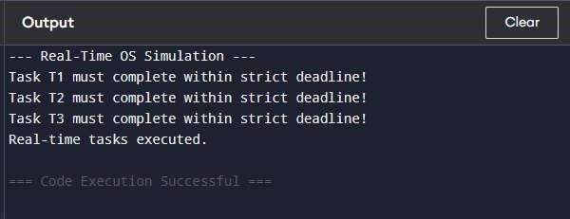

EXPERIMENT – 2
Simulate CPU scheduling algorithms (FCFS, SJF, Round Robin, Priority). Generate Gantt chart, compute average waiting and turnaround time.

(1) FCFS (First-Come, First-Served)
CODE:
# FCFS Scheduling Simulation n = 3 # number of processes processes = []

print("--- FCFS Scheduling ---") for i in range(n):
name = "P" + str(i+1) at =
int(input(f"Arrival time of {name}: ")) bt = int(input(f"Burst time of {name}: ")) processes.append([name, at, bt])

# Sort by Arrival Time processes.sort(key=lambda x: x[1])

time = 0 wt = [] tat = [] gantt =
[]

for p in processes: name, at, bt = p
if time < at:
time = at
wt.append(time - at) time += bt tat.append(time -
at)
gantt.append(name)

# Output print("\nGANTT CHART:", " | ".join(gantt)) print("\nProcess WT TAT") for i, p in enumerate(processes):
print(f"{p[0]} {wt[i]} {tat[i]}")
print(f"\nAverage WT={sum(wt)/n:.2f} Average TAT={sum(tat)/n:.2f}")

OUTPUT-

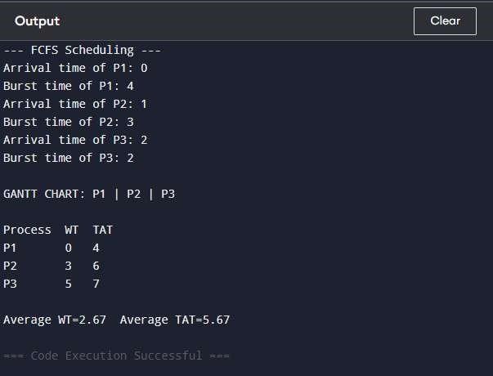
(2) SJF (Non-Preemptive)
CODE:
# SJF Scheduling Simulation (Non-preemptive) n
= 3 processes = [] print("--- SJF (Non-
preemptive) Scheduling ---") for i in range(n):
name = "P" + str(i+1) at =
int(input(f"Arrival time of {name}: ")) bt = int(input(f"Burst time of {name}: ")) processes.append([name, at, bt])

time = 0 completed = 0 visited = [False]*n
wt = [0]*n tat = [0]*n gantt = []
while completed < n:
idx = -1 min_bt =
9999 for i in range(n):
if processes[i][1] <= time and not visited[i] and processes[i][2] < min_bt:
min_bt = processes[i][2] idx = i if idx == -1: time += 1
continue visited[idx] = True
gantt.append(processes[idx][0]) wt[idx] =
time - processes[idx][1] time += processes[idx][2] tat[idx] = time - processes[idx][1] completed += 1 # Output print("\nGANTT CHART:", " | ".join(gantt)) print("\nProcess WT TAT") for i, p in enumerate(processes):
print(f"{p[0]} {wt[i]} {tat[i]}")
print(f"\nAverage WT={sum(wt)/n:.2f} Average TAT={sum(tat)/n:.2f}")

OUTPUT-

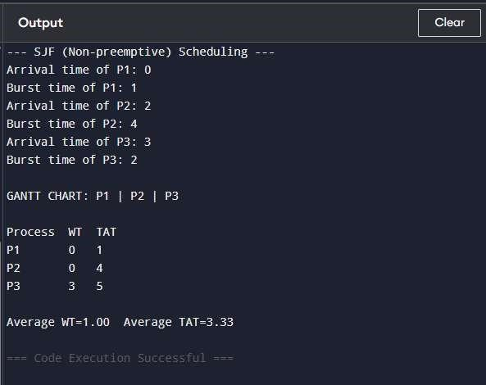
(3) Priority Scheduling (Non-Preemptive) CODE:
# Priority Scheduling (Non-preemptive) n
= 3
processes = []

print("--- Priority Scheduling ---") for i in range(n):
name = "P" + str(i+1) at = int(input(f"Arrival time of {name}: ")) bt = int(input(f"Burst time of {name}: ")) pr = int(input(f"Priority of {name} (lower = higher): ")) processes.append([name, at, bt, pr])

# Sort by Priority then Arrival processes.sort(key=lambda x: (x[3], x[1]))

time = 0 wt = [] tat = [] gantt =
[]

for p in processes: name, at, bt, pr = p if time < at: time = at wt.append(time -
at) time += bt
tat.append(time - at) gantt.append(name)

# Output print("\nGANTT CHART:", " | ".join(gantt)) print("\nProcess WT TAT") for i, p in enumerate(processes):
print(f"{p[0]} {wt[i]} {tat[i]}")
print(f"\nAverage WT={sum(wt)/n:.2f} Average TAT={sum(tat)/n:.2f}")

OUTPUT-

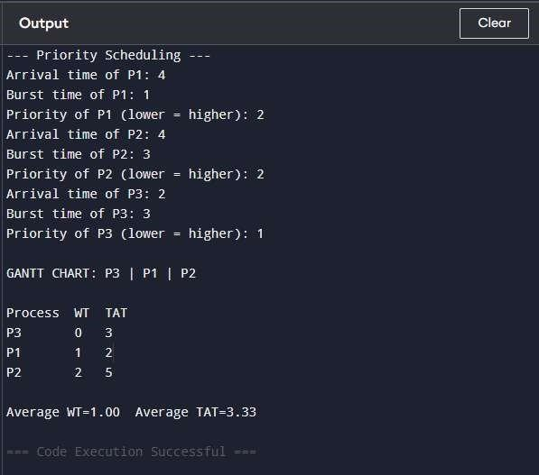
(4) Round Robin
CODE:
# Round Robin Scheduling n
= 3
processes = []

print("--- Round Robin Scheduling ---") for i in range(n):
name = "P" + str(i+1) at =
int(input(f"Arrival time of {name}: ")) bt = int(input(f"Burst time of {name}: ")) processes.append([name, at, bt])

quantum = int(input("Enter Time Quantum: ")) remaining = [p[2] for p in processes] wt = [0]*n tat = [0]*n time = 0 queue = list(range(n)) gantt
= [] while queue: i = queue.pop(0) name, at, bt = processes[i] if remaining[i] > quantum: gantt.append(name) time += quantum
remaining[i] -= quantum queue.append(i)
else:
gantt.append(name)
time +=
remaining[i] wt[i] = time - at - bt tat[i] =
time - at
remaining[i] = 0
# Output print("\nGANTT CHART:", " | ".join(gantt)) print("\nProcess WT TAT") for i, p in enumerate(processes):
print(f"{p[0]} {wt[i]} {tat[i]}")
print(f"\nAverage WT={sum(wt)/n:.2f} Average TAT={sum(tat)/n:.2f}")

OUTPUT-

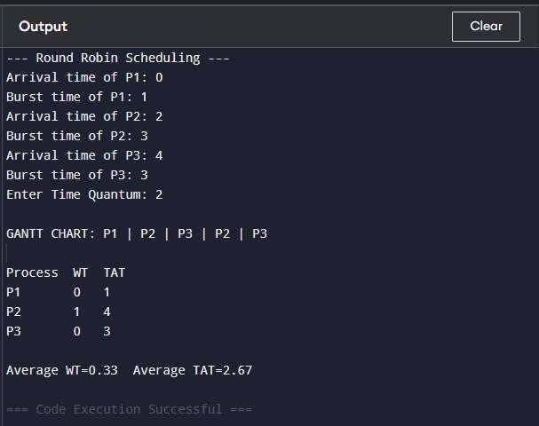

EXPERIMENT – 3
Simulate Worst-fit, Best-fit, and First-fit memory allocation.

(1) First-Fit Memory Allocation
CODE:
# First-Fit Memory Allocation
print("--- First-Fit Memory Allocation ---")

# Input memory blocks blocks = [10, 20, 15] # Input process sizes
processes = [12, 5, 8]

allocation = [-1] * len(processes)

for i, p_size in enumerate(processes):
for j, b_size in enumerate(blocks):
if b_size >= p_size: allocation[i] = j
blocks[j] -=
p_size break

# Output print("\nProcess Size Block
Allocated") for i,  enumerate(processes): if allocation[i] != -1: | p in
print(f"P{i+1} {p} else: | B{allocation[i]+1}")
print(f"P{i+1} {p} | Not Allocated")

OUTPUT-

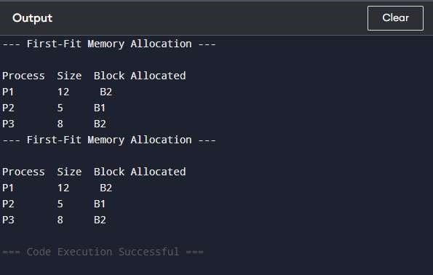

(2) Best-Fit Memory Allocation
CODE:
# Best-Fit Memory Allocation
print("--- Best-Fit Memory Allocation ---")

blocks = [10, 20, 15]
processes = [12, 5, 8]

allocation = [-1] * len(processes) for i, p_size in enumerate(processes): best_idx = -1 for j, b_size in enumerate(blocks):
if b_size >= p_size:
if best_idx == -1 or b_size < blocks[best_idx]:
best_idx = j if best_idx != -1: allocation[i] = best_idx blocks[best_idx]
-= p_size

# Output print("\nProcess Size Block
Allocated") for i,  enumerate(processes): if allocation[i] != -1: | p in
print(f"P{i+1} {p}  else: | B{allocation[i]+1}")
print(f"P{i+1} {p} | Not Allocated")

OUTPUT-

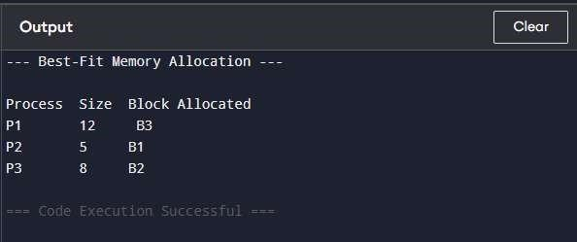
(3) Worst-Fit Memory Allocation
CODE:
print("--- Worst-Fit Memory Allocation ---")

blocks = [10, 20, 15] processes
= [12, 5, 8]
allocation = [-1] * len(processes)

for i, p_size in enumerate(processes): worst_idx = -1 for j, b_size in enumerate(blocks):
if b_size >= p_size:
if worst_idx == -1 or b_size > blocks[worst_idx]:
worst_idx = j if worst_idx != -1:
allocation[i] = worst_idx blocks[worst_idx]
-= p_size
# Output print("\nProcess Size Block
Allocated") for i,  enumerate(processes): if allocation[i] != -1: | p in
print(f"P{i+1} {p}  else: | B{allocation[i]+1}")
print(f"P{i+1} {p}  OUTPUT- | Not Allocated")

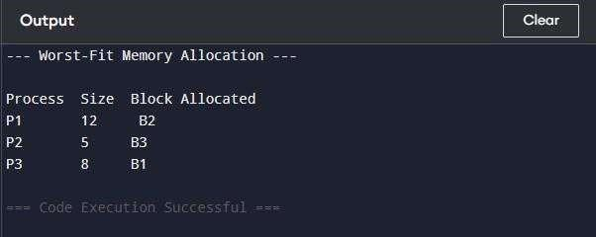

EXPERIMENT – 4
Implement Banker’s Algorithm for deadlock avoidance/prevention.

(1) Deadlock Avoidance (Banker’s Algorithm)
CODE:
# Banker’s Algorithm — Deadlock Avoidance
print("--- Banker’s Algorithm for Deadlock Avoidance ---")

# Number of processes and resources n
= 3 # processes
m = 3 # resources

# Maximum resources needed by each process max_resources
= [
[7, 5, 3],
[3, 2, 2],
[9, 0, 2]
]

# Currently allocated resources allocated
= [
[0, 1, 0],
[2, 0, 0],
[3, 0, 2]
]

# Available resources
available = [3, 3, 2]

# Calculate Need matrix
need = [[max_resources[i][j] - allocated[i][j] for j in range(m)] for i in range(n)]

print("\nNeed Matrix:") for i in range(n):
print(f"P{i+1}: {need[i]}")

# Safety Algorithm finish = [False]*n safe_seq = []

while len(safe_seq) < n:
allocated_in_round = False for i in range(n):
if not finish[i] and all(need[i][j] <= available[j] for j in range(m)):
for j in range(m):
available[j] +=
allocated[i][j] finish[i] = True safe_seq.append(f"P{i+1}") allocated_in_round = True if not allocated_in_round: break

# Output if
len(safe_seq) == n: print("\nSystem is in SAFE state
(Avoidance).") print("Safe
sequence:", " ->
".join(safe_seq)) else:
print("\nSystem is in UNSAFE state. Deadlock may occur.")

OUTPUT-

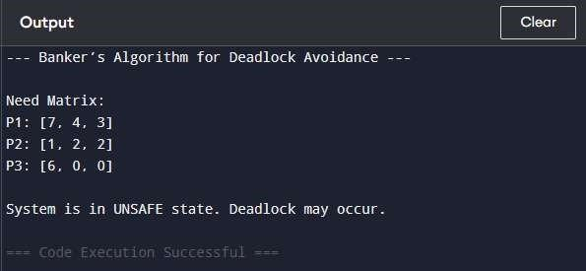

(2) Deadlock Prevention (Banker’s Algorithm / Resource Allocation Limits)
CODE:
# Banker’s Algorithm — Deadlock Prevention print("---
Banker’s Algorithm for Deadlock Prevention ---")
# Total resources total
= [10, 5, 7]
# Maximum resources needed by each process max_resources
= [
[7, 5, 3],
[3, 2, 2],
[9, 0, 2]
]
# Currently allocated resources allocated
= [
[0, 1, 0],
[2, 0, 0],
[3, 0, 2]
]
# Available resources available = [total[i] - sum(allocated[j][i] for j in range(len(allocated))) for i in
range(3)] print("Available resources:", available)
# Simple prevention: do not allow allocation if request > (total - 1) for i, req in enumerate(max_resources):
if any(req[j] > total[j] - 1 for j in range(len(req))):
print(f"Request by P{i+1} denied (prevention).") else:
print(f"Request by P{i+1} can be allocated safely.")

OUTPUT-

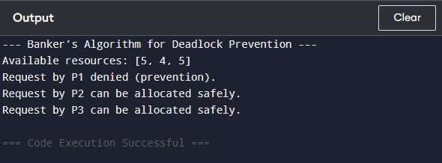

EXPERIMENT – 5
Implement Producer-Consumer problem using semaphores.

CODE:
# Producer-Consumer Problem using Semaphores import threading import time import random

# Buffer and semaphores buffer
= []
buffer_size = 2

empty = threading.Semaphore(buffer_size) # empty slots full
= threading.Semaphore(0) # full slots
mutex = threading.Semaphore(1) # mutual exclusion

# Producer function def producer(items):
for item in items: empty.acquire() mutex.acquire() buffer.append(item)
print(f"Produced: {item} | Buffer: {buffer}")
mutex.release() full.release()
time.sleep(random.uniform(0.1, 0.5))
# Consumer function def consumer(n): for _ in range(n): full.acquire() mutex.acquire() item = buffer.pop(0) print(f"Consumed: {item} | Buffer: {buffer}") mutex.release() empty.release() time.sleep(random.uniform(0.1, 0.5))

# Sample items to produce items_to_produce = [1, 2, 3] num_items = len(items_to_produce)

# Threads t1 = threading.Thread(target=producer,
args=(items_to_produce,)) t2 =
threading.Thread(target=consumer, args=(num_items,))

# Start threads t1.start() t2.start()

# Wait for completion t1.join() t2.join() print("Producer-
Consumer
Simulation
Completed.")

OUTPUT-

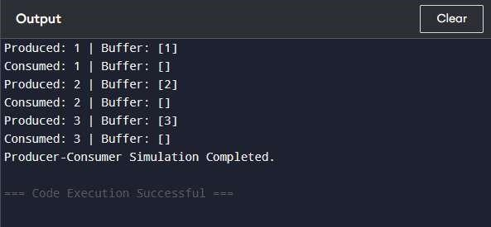

EXPERIMENT – 6
Process synchronization using semaphores.
CODE:
# Process Synchronization using Semaphores import threading
import time

# Shared resource shared_counter
= 0
# Semaphore for mutual exclusion mutex =
threading.Semaphore(1) # Process 1 function def process1(): global shared_counter for i in range(3): mutex.acquire() shared_counter += 1 print(f"Process 1 incremented counter to
{shared_counter}") mutex.release()
time.sleep(0.2)

# Process 2 function def
process2(): global
shared_counter for i in range(3):
mutex.acquire() shared_counter += 1 print(f"Process 2
incremented counter to {shared_counter}") mutex.release() time.sleep(0.3)

# Create threads t1 =
threading.Thread(target=process1) t2 = threading.Thread(target=process2)

# Start threads t1.start() t2.start()

# Wait for completion t1.join() t2.join()

print("Final value of shared counter:", shared_counter) print("Process
Synchronization Simulation Completed.")

OUTPUT-

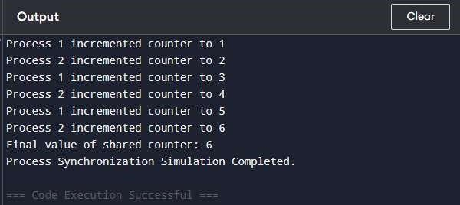

EXPERIMENT – 7
Use UNIX/Linux I/O system calls (open, read, write, close, seek, stat).
CODE:
import io

print("--- File I/O Simulation (Programiz-Friendly) ---")

# Create an in-memory file f
= io.StringIO()

# Write to "file" text = "Hello OS Lab\n"
f.write(text)
print(f"Written to file: {text.strip()}")

# Move file pointer to beginning
f.seek(0)
print("File pointer moved to beginning")

# Read from "file" content
= f.read()
print("Read from file:", content.strip())

# Simulate file info size = len(content.encode()) print("File info (simulated):") print(f"Size: {size} bytes") print(f"Permissions:
Simulated as 0o666")

# Close "file"
f.close() print("File closed")

OUTPUT-

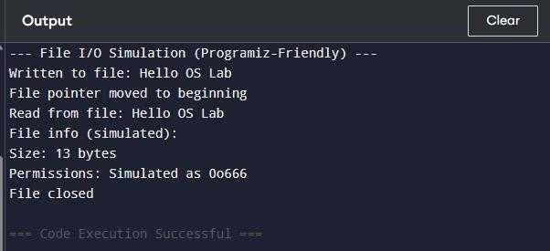

EXPERIMENT – 8
System Startup, Process Creation, and Termination Simulation in Python.
(1) System Startup Stimulation

CODE:
print("=== SYSTEM STARTUP SIMULATION ===")

boot_steps = [
"Powering on...",
"Running BIOS...",
"Checking hardware...",
"Loading Operating System...",
"Starting system services...",
"System Ready!"
]
for step in boot_steps: print(step)

OUTPUT-

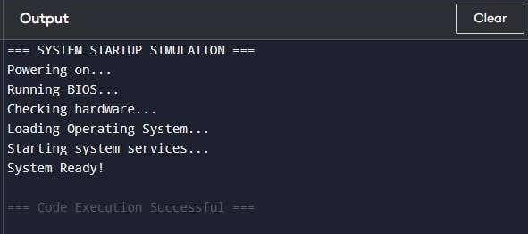
- Process Creation Stimulation
CODE:
print("=== PROCESS CREATION SIMULATION ===")
num = int(input("Enter number of processes to create: "))

process_table = []

for i in range(num): name = input(f"Enter name for Process {i+1}: ") pid = 2000 + i process_table.append((pid, name)) print(f"Process Created → PID: {pid}, Name: {name}") print("\nProcess Table:") for pid, name in process_table: print(f"PID: {pid} | Name: {name}")

OUTPUT-

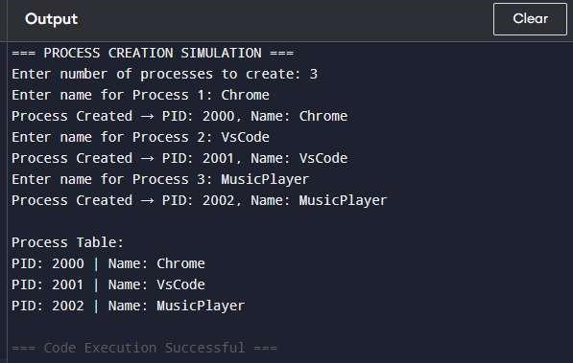
- Process Termination Simulation
CODE:
print("=== PROCESS TERMINATION SIMULATION ===")

# Preloaded process table for demonstration process_table
= [
(3000, "Chrome"),
(3001, "Notepad"),
(3002, "Camera")
]

print("Current Processes:") for pid, name in process_table: print(f"PID:
{pid} | Name: {name}")

pid_to_terminate = int(input("\nEnter PID to terminate: "))

found = False for p in process_table:
if p[0] == pid_to_terminate: found = True
process_table.remove(p) print(f"Process Terminated →
PID: {pid_to_terminate}") break

if not found: print("Invalid PID! No such process.")
print("\nUpdated Process Table:") if len(process_table) == 0:
print("No active processes.") else:
for pid, name in process_table: print(f"PID: {pid} | Name: {name}")

OUTPUT-

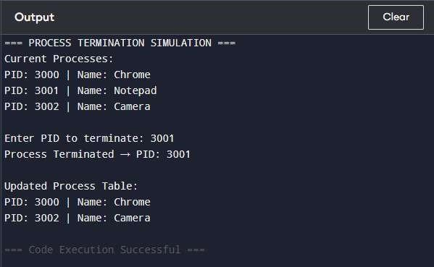

EXPERIMENT – 9
Create and manipulate threads in Python.

(1) Create “Threads”
CODE:
import time

print("=== THREAD CREATION SIMULATION ===")

def task1(): print("Task 1 started") time.sleep(1)
print("Task 1 completed")

def task2(): print("Task 2 started") time.sleep(1)
print("Task 2 completed")

print("Creating Thread 1...") task1()
print("Creating Thread 2...") task2()

print("All tasks finished (Simulated Threads)")
OUTPUT-

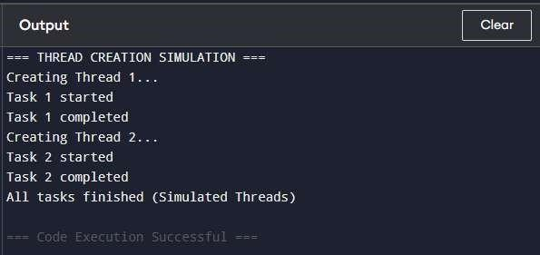

(2) Parallel Execution
CODE:
import time

print("=== THREAD INTERLEAVING SIMULATION ===")

def threadA():
for i in range(3): print(f"Thread A → Step {i+1}") time.sleep(0.5)

def threadB():
for i in range(3): print(f"Thread B → Step {i+1}") time.sleep(0.5)

print("Starting simulated parallel execution...\n") for i in range(3): threadA() threadB()

print("\nSimulation Complete")

OUTPUT-

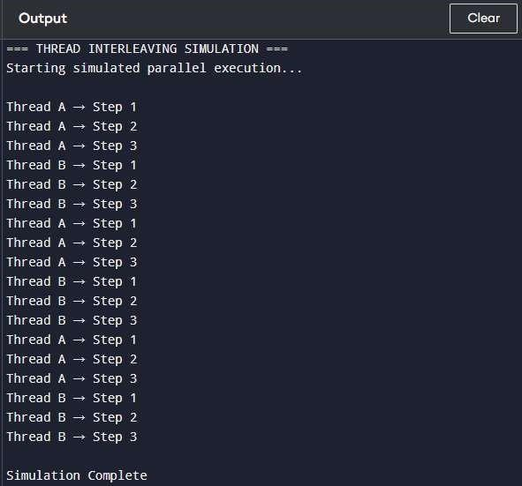
(3) Start, Pause, Resume “Threads”
CODE:
import time

print("=== THREAD CONTROL SIMULATION ===")

def worker(): print("Thread started") time.sleep(1) print("Thread paused...") time.sleep(1) print("Thread resumed") time.sleep(1) print("Thread finished")

worker()

OUTPUT-

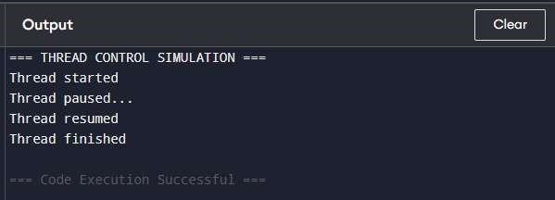

EXPERIMENT – 10
Process Creation and Management Using Python OS Module.

- Simulate Process Creation
CODE:
print("=== PROCESS CREATION (SIMULATED OS MODULE) ===")

def create_process(name, pid):
print(f"Creating process: {name}") print(f"Assigned PID: {pid}")

process_name = input("Enter process name: ") pid
= 5000

create_process(process_name, pid) print("Process created successfully!")

OUTPUT-

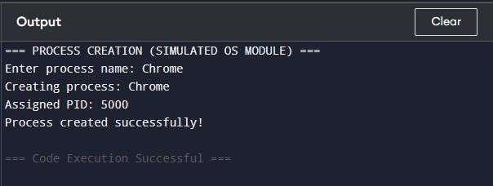
- Simulate Process Table
CODE:
print("=== PROCESS TABLE SIMULATION ===")

processes = [
(1001, "System"),
(1002, "Chrome"),
(1003, "MusicApp")
]

print("PID\tProcess Name")
print(" ")
for pid, name in processes:
print(f"{pid}\t{name}")

OUTPUT-

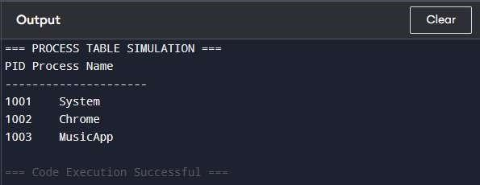
(3) Process Termination
CODE:
print("=== PROCESS TERMINATION SIMULATION ===")

process_table = [
(6000, "Chrome"),
(6001, "Notes"),
(6002, "WhatsApp")
]

print("Current Processes:") for pid, name in process_table: print(f"PID:
{pid} | Name: {name}")

pid_to_kill = int(input("\nEnter PID to terminate: "))

found = False for p in process_table:
if p[0] == pid_to_kill: process_table.remove(p) print(f"Process {pid_to_kill} terminated (simulated)") found = True
break

if not found:
print("No such process!")
print("\nUpdated Process Table:") for pid, name in process_table:
print(f"PID: {pid} | Name: {name}")

OUTPUT-

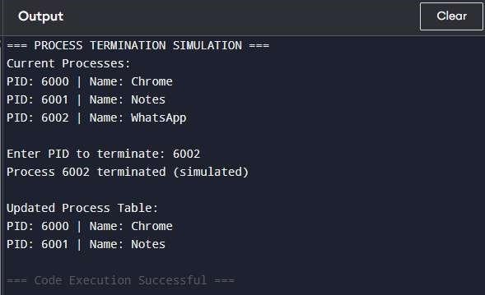

EXPERIMENT – 11
File System Operations using Python

- Create & Write to File
CODE:
from io import StringIO

print("=== FILE CREATION & WRITE OPERATION (SIMULATED) ===")

file = StringIO() # virtual in-memory file

file.write("Hello OS Lab\n")
file.write("This is a write operation in a simulated file.")

print("File created and written successfully (SIMULATED FILE).")

OUTPUT-

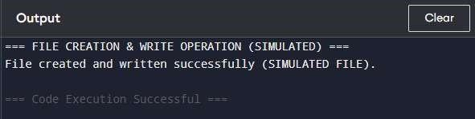
- Read File Content CODE:
from io import StringIO

print("=== FILE READ OPERATION (SIMULATED) ===")

# Create virtual file again (since Programiz resets each run)
file = StringIO("Hello OS Lab\nThis is a write operation in a simulated file.")

file.seek(0)
content = file.read()

print("File Content:") print(content)

OUTPUT-

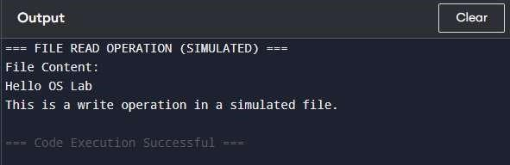
- File “Stat”
CODE:
from io import StringIO import time

print("=== FILE INFORMATION (STAT SIMULATION) ===")

data = "Hello OS Lab\nThis is a write operation in a simulated file." virtual_file = StringIO(data)

size = len(data.encode()) created = time.ctime() modified = time.ctime()

print(f"Filename: simulated_file.txt")
print(f"Size: {size} bytes") print(f"Created: {created}")
print(f"Modified: {modified}")

OUTPUT-

